**Assignment 1**

**Tasks to be performed:**

Create an EFS and connect it to 3 different EC2 instances. Make sure that all instances have different operating systems. For instance, Ubuntu, Red Hat Linux and Amazon Linux 2.

**Solution:**

Step 1:- Creating 3 EC2 Instances of Ubuntu, RedHat & Amazon Linux. Make sure to enable SSH & NFS port in the Security Groups for the EC2.

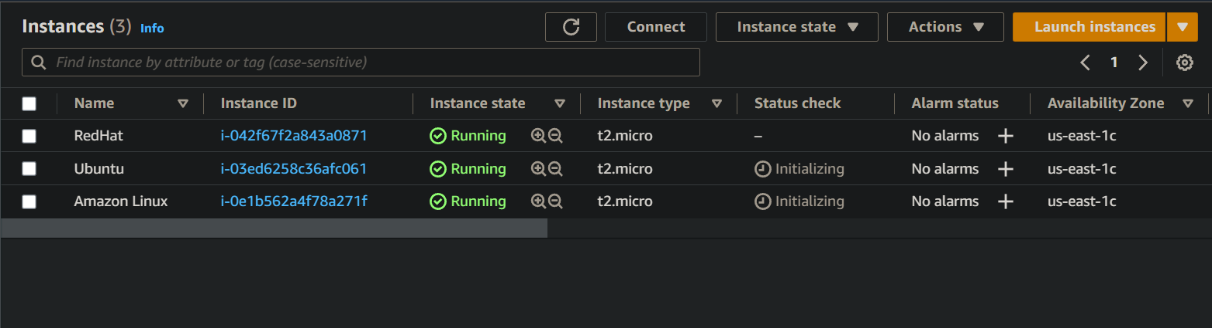

Step 2:- Run apt install nfs-common -y command in Ubuntu EC2 & sudo yum install nfs-utils -y command in RedHat EC2.

**Ubuntu:**

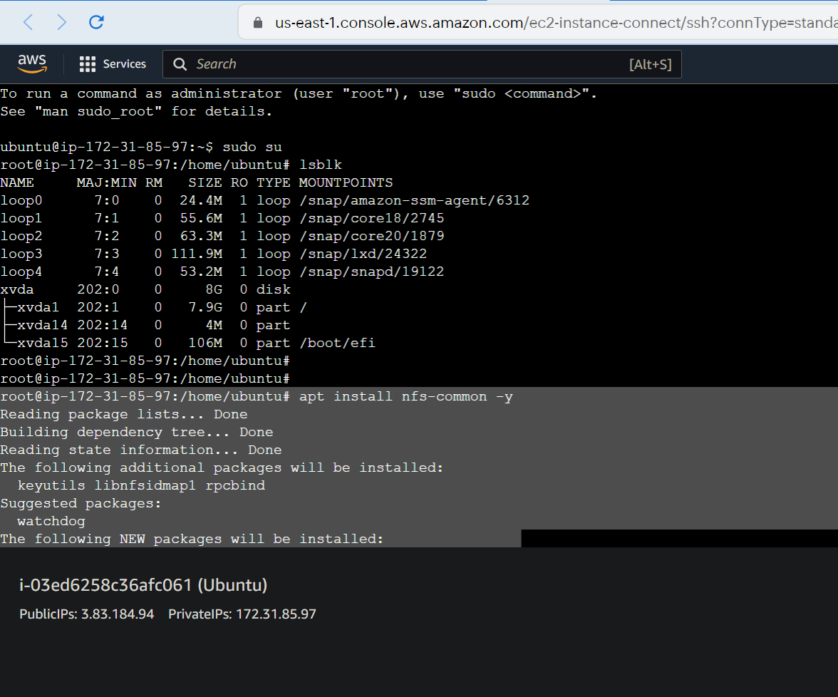

**RedHat:**

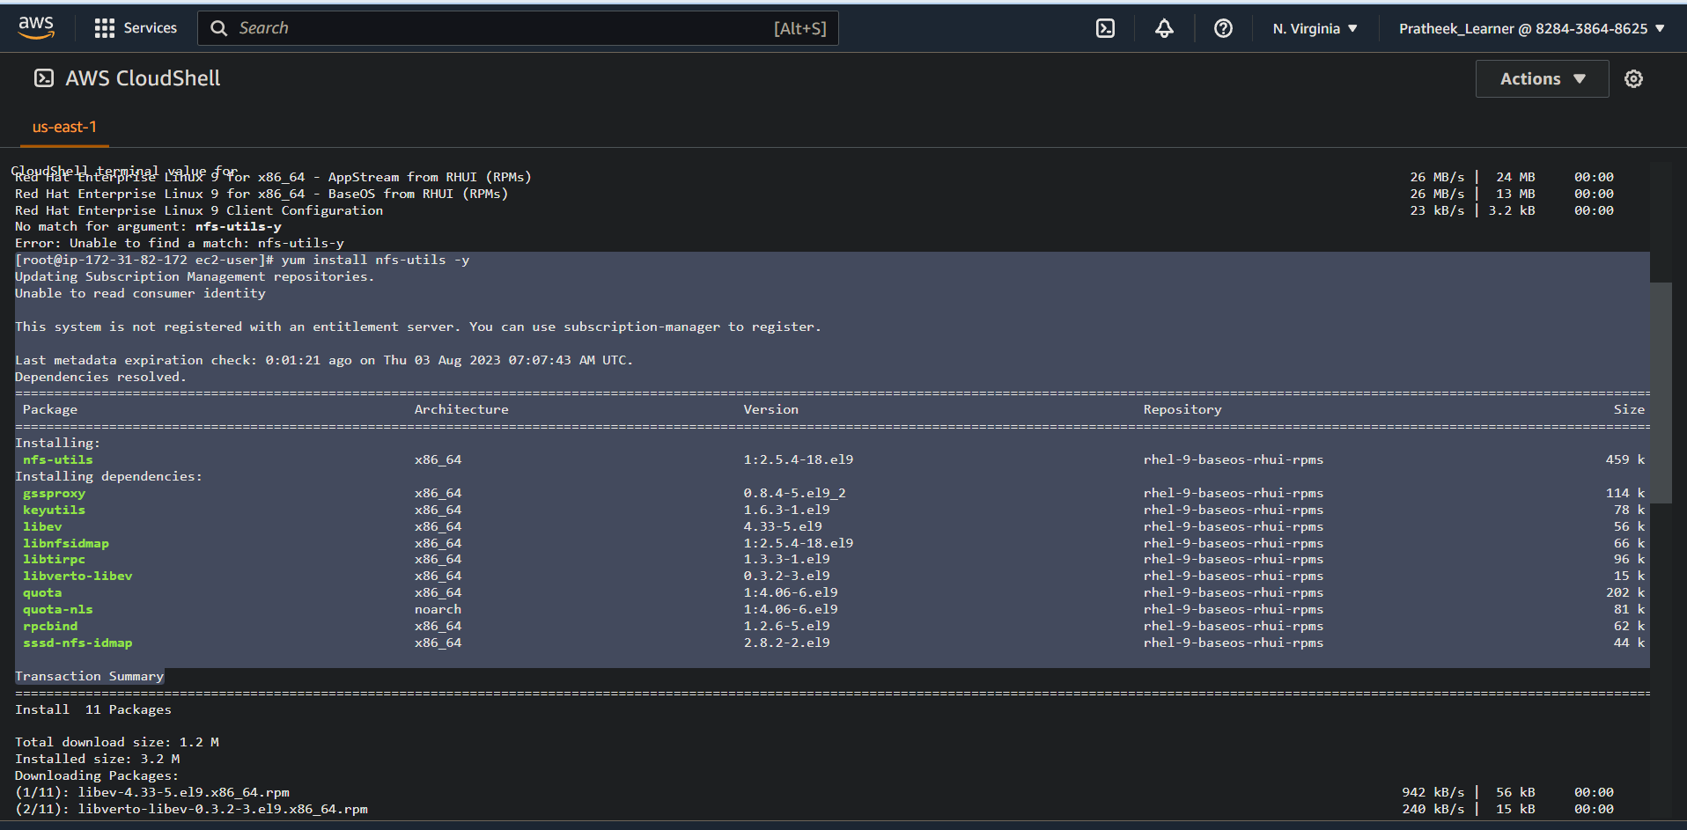

Step 3:- Create an EFS system for the above EC2

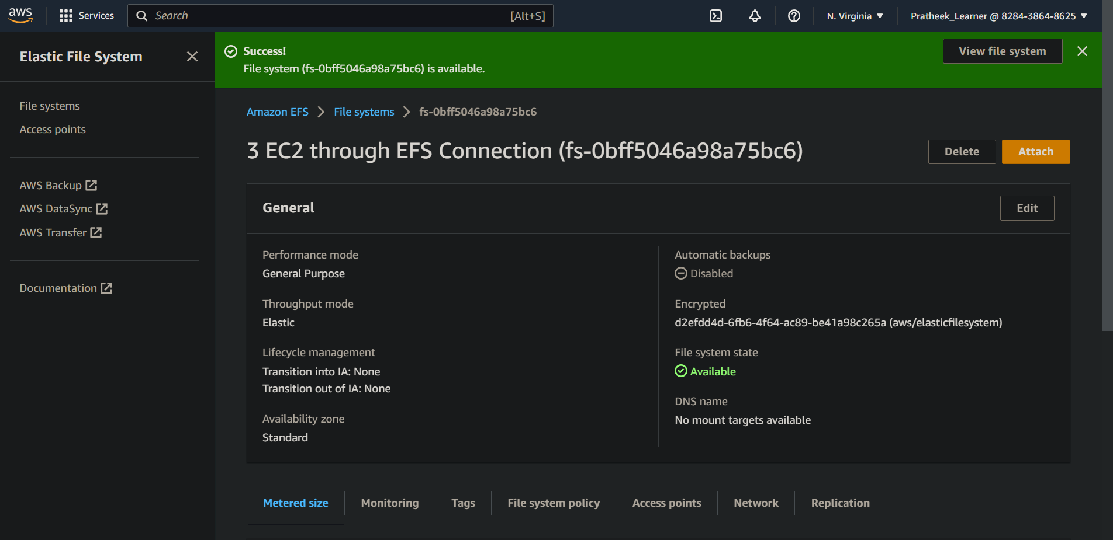

Step 4:- Create a directory in each instances so as to mount the EFS.

Step 5:- Then attach the EFS using the command provided in the attach section of EFS.

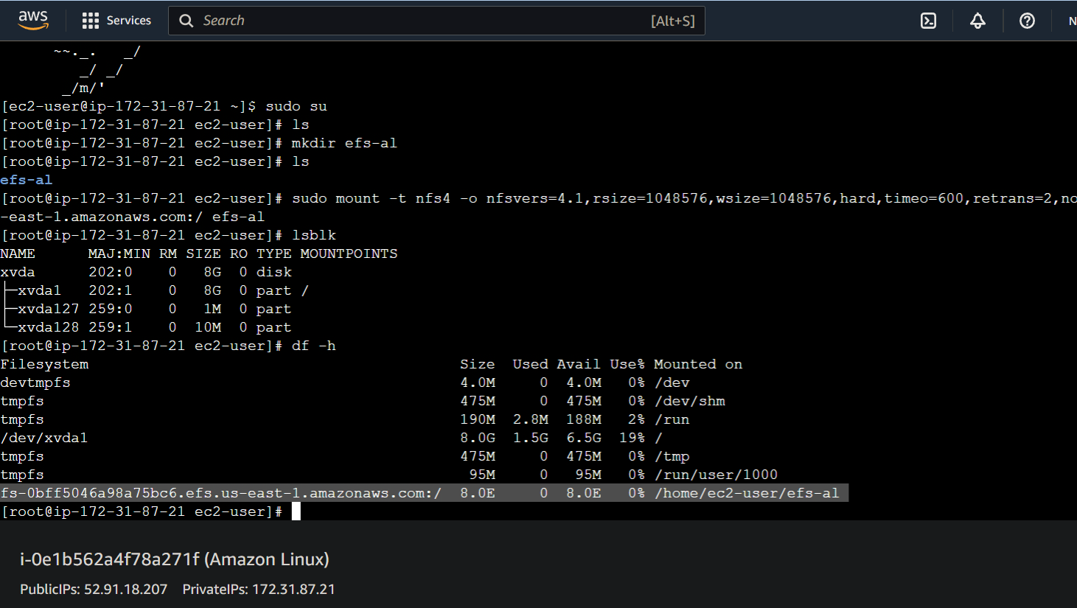

Step 6:- Create a file in one of the EC2 instance inside the EFS mount point folder & the file should appear on all the other EC2 EFS mount file points.

